COMPARATIVE FORM (COMPARATIVOS)

OA16 : Demostrar conocimiento y uso del lenguaje por medio de las siguientes funciones: Expresar cantidades, comparar, contar y enumerar.
OBJ: Describen personas, objetos, etc. Usando la estructura gramatical comparativa.

Name: ____________________________________

La forma comparativa en inglés es usada para comparar un objeto, animal, persona o cosa con otra. Se consideran adjetivos cortos (Short words) los que tiene una sola sílaba como old, a estos se les agrega la terminación -ER, mientras que los adjetivos largos (long words) poseen 2 o más silabas como dangerous y se antepone la palabra MORE antes del adjetivo.
Observa el cuadro de ejemplos:

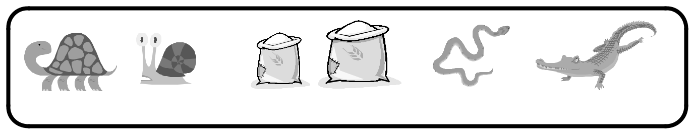

SLOW SLOWER - HEAVY / HEAVIER - DANGEROUS /MORE DANGEROUS

Write comparative sentences using the verbs in brackets

- My house is (big) _____________than yours.
- This flower is (beautiful) _________________than that one.
- A holiday by the sea is (good) ____________than a holiday in the mountains.

- The weather this summer is even (bad) __________than last summer.

- I think mathematics is (difficult) _____________than English.

Complete the sentences. Use the comparative.

- Joe’s car isn’t very fast. He wants a __________ one.
- My job isn’t very interesting. I want to do something ___________________

- The weather isn’t very warm today. Yesterday it was ___________________

- People aren’t very polite today. In the past they were ___________________
- This sofa isn’t very comfortable. That one is _____________________

- This coat is nice, but I think the other one is ______________

Compare your favorite actor or actress with this outstanding character.
(te invito a indagar sobre Rosa Paraks, si me cuentas como te sentiste al conocer más de ella tendrás puntos extra 😊)

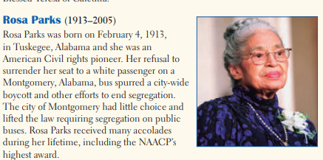

YOUR CHARACTER INFORMATION:
___________________________________________________________________
___________________________________________________________________________________________________________________________________________________________________________________________________________________ ____________________________________________________________________ ___________________________________________________________________

COMPARE BOTH CHARACTERS
Rosa parks | ………………………..

