**Guía de trabajo N° 5**

**Unit 1 *“Globalization and Communication”***

**Idioma Extranjero Inglés**

**Semana 14**

|  |  |  |
| --- | --- | --- |
| **ASIGNATURA: inglés** | **CURSO: 2°A** | **PROFESOR(A): María José Sepúlveda.** |
| **Nombre:** | | **Correo:**  **maria.sepulveda@liceosantacruzdetriana.cl** |
| **Fecha:** | |
| **Objetivo de Aprendizaje: OA9** Demostrar comprensión de ideas generales e información explícita en textos adaptados y auténticos simples, en formato impreso o digital, acerca de temas variados.  **Objetivo de la clase:** Relacionar contexto del texto con los conectores, para inferir significado de ellos.  **INSTRUCCIONES:**  *Cada sección está dividida en dos colores, Negro (Inglés) y Morado (Español).   * 1. Clasificar los conectores en el recuadro.   2. Completar texto con los conectores incluidos en el material de estudio n°9, para luego extraer la idea principal   del texto   * 1. Enviar todo a los correos señalados según corresponda el curso.   2. Responde utilizando lápiz pasta, negro o azul, **no usar lápiz grafito.**   3. Escribe claro, así leeremos mejor tus respuestas.   4. Con el 60% de la evaluación buena obtienes un 4.0, pero puedes tener una mejor nota.   5. Ahora empieza a trabajar. ¡Éxito! | | |

**HOW TO DESCRIBE AN OBJECT?**

COLOUR(S): What colour is it?

Red - white

SHAPE: What shape is it?

round – tube

SIZE: How big is it?

Long - thin

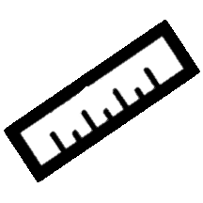



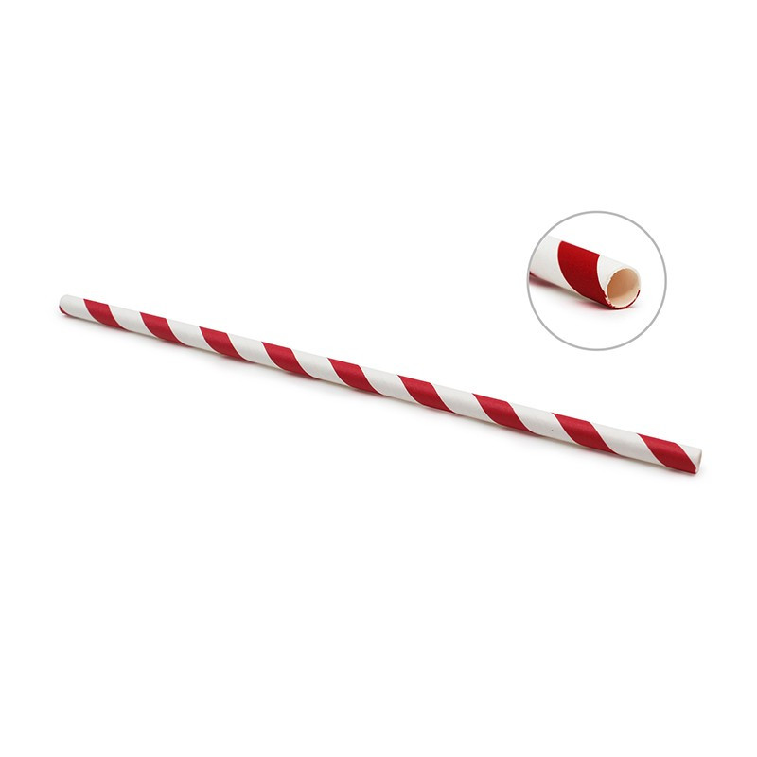

MATERIALS: What is it made of?

Paperboard

PAPER STRAW

PURPOSE: What is it used for?

Drink



DESCRIPTION:

**A *Paper Straw* is long and thin, its shape is round and it looks like a tube. It can be many colours, but this is not only white but also red. It is made of paperboard and it is used to drink cold liquids, like drinks, iced tea, shakes, etc.**

NOW IS YOUR TURN TO DESCRIBE YOUR OWN OBJECT! / ¡AHORA ES TÚ TURNO DE DESCRIBIR TU PROPIO OBJETO!

HOW DO I DO IT? / ¿CÓMO LO HAGO?

1. Create your own technological-ecological object. /Crea tu propio objeto tecnológico y ecológico.
2. In the TABLE N°1, write adjectives for your object. / En la TABLA N°1, escribe adjetivos para tu objeto (Tabla N°1).
3. Describe your object. *Use the example of the *paper straw* to help yourself (Table N°2). / Describe tu objeto. *Usa el ejemplo de la *bombilla de papel* para ayudarte (Tabla N°2).
4. To describe your object, use the connectors from the previous class. / Para describir tu objeto, utiliza los conectores de la clase anterior.

Table N°1

|  |
| --- |
| **MATERIALS (what is it made of?): _______________________________________________________**  **________________________________________________________________________________________** |
| **SIZE (how big is it?): ____________________________________________________________________**  **_________________________________________________________________________________________** |
| **COLOURS (what colour is it?): _____________________________________________________________**  **__________________________________________________________________________________________** |
| **SHAPE (what shape is it?): ________________________________________________________________**  **__________________________________________________________________________________________** |
| **PURPOSE (what is it for?): ________________________________________________________________**  **__________________________________________________________________________________________** |

Table N°2

|  |
| --- |
| **DESCRIBE THE OBJECT: _________________________________________________________________________________________**  **_________________________________________________________________________________________**  **_________________________________________________________________________________________**  **_________________________________________________________________________________________**  **_________________________________________________________________________________________**  **_________________________________________________________________________________________** |